**Activity: Disabling helper queries**

[AdventureWorksSales](https://d3c33hcgiwev3.cloudfront.net/aRCpkrl0TUyh9x2mHWg_5g_4d4dc230247e4abcbae887602bb3f4e1_AdventureWorksSales.zip?Expires=1709856000&Signature=Zzli9Vp~9ZQo0WSLrN0-yWq~0qa1Gvr8e6kxhNvmLNprHlwfnQaToepfvtpSkzie~-ueQwhVQ8Fexhr-77MwB7zhhXEtZKCyBhcl33EDBC6nValXQ--mEvSu~Id3Z0vTKHxyGKGCileETPgXCsIOFA7bbguBE96T~PuQFU3CIIk_&Key-Pair-Id=APKAJLTNE6QMUY6HBC5A" \t "_blank)

[ZIP File](https://d3c33hcgiwev3.cloudfront.net/aRCpkrl0TUyh9x2mHWg_5g_4d4dc230247e4abcbae887602bb3f4e1_AdventureWorksSales.zip?Expires=1709856000&Signature=Zzli9Vp~9ZQo0WSLrN0-yWq~0qa1Gvr8e6kxhNvmLNprHlwfnQaToepfvtpSkzie~-ueQwhVQ8Fexhr-77MwB7zhhXEtZKCyBhcl33EDBC6nValXQ--mEvSu~Id3Z0vTKHxyGKGCileETPgXCsIOFA7bbguBE96T~PuQFU3CIIk_&Key-Pair-Id=APKAJLTNE6QMUY6HBC5A" \t "_blank)

**Introduction**

As a member of the data analytics team at Adventure Works, your job involves wrangling a large amount of data from different regions. One morning, you receive an email containing CSV files. You must combine these multiple files into a coherent report for the quarterly review meeting at noon.

Feeling under pressure, you turn to your most trusted ally in these situations –Microsoft Power BI. As you navigate through Power BI's features and begin the data integration process, you notice a peculiar pattern. Power BI is generating many additional queries alongside your primary one. These helper queries are automatically crafted by Power Query when you combine files from a folder.

First, it feels like a smart feature, but then you soon notice unfavorable consequences. Your Query Editor is gradually filling up, cluttered with more queries than you find useful, thereby slowing you down. You find yourself wanting a cleaner, more streamlined process. You ask yourself: "Is there a way to manage or disable these extra queries?" Let's uncover the mystery behind these helper queries and equip you with the knowledge to modify their behavior.

This reading helps you to understand the role of helper queries in Power BI Desktop. It explains how and why you might want to disable these helper queries.

**What are Helper Queries?**

In Power BI Desktop, a helper query is a sequence of steps used to perform some sort of data preparation or transformation. Helper queries run every time you refresh your data, ensuring that your data is always in the right shape for analysis. Despite their utility, there could be scenarios when you want to disable these helper queries. Performance could be one reason. Every query in Power BI Desktop consumes computer memory and processing power. If you’re working with large datasets or complex transformations, running too many queries can slow down your report refreshes. There may also be times when the data shape required by a specific part of your report changes, and the associated helper query is no longer required. In such cases, you can disable these helper queries to ensure they don’t consume unnecessary resources.

**Activity: Disabling Helper Queries**

Now, lets follow the steps to disable helper queries.

1. First, download the *AdventureWorksSales.zip* and unzip the file to a folder. **Tip:** Right-click the zip file and select Extract All. In this extracted folder there will be a *Disabling Helper Queries* Power BI file and a *Data* folder.
2. From the Microsoft Power BI interface's top left corner select **File,** and then select **Open Report**.  Locate and select the *Disabling Helper Queries* report file on your system. Once the report is loaded, you will see multiple tabs at the top of the screen, including **Home**, **View**, **Insert**, **Modeling**, etc. Select the **Home** tab.

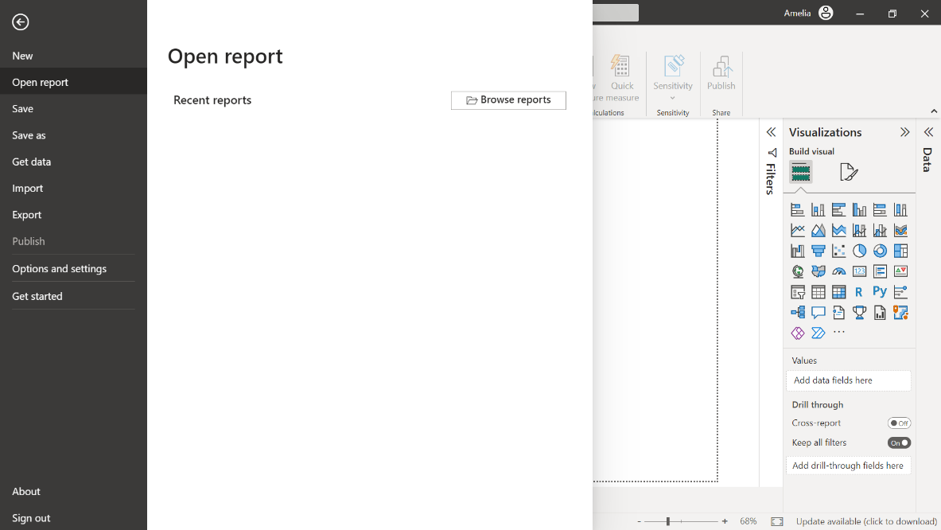

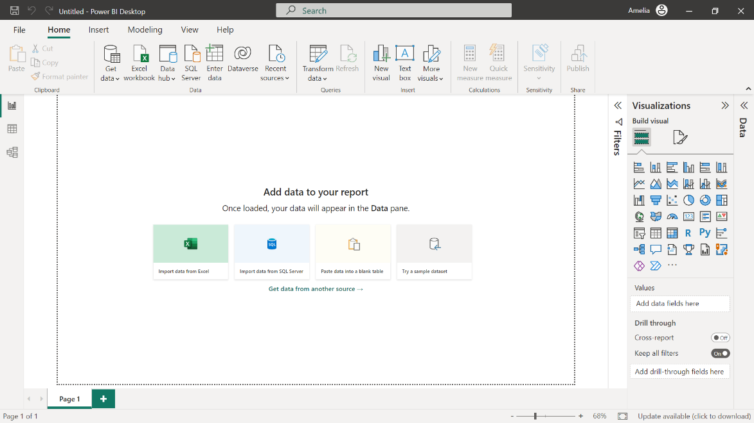

1. On the **Home** tab, select **Transform Data** dropdown and then **Data Source Settings**. Select **Change Source** and change the source to the *Data* folder in the *AdventureWorksSales* folder. Click **Close**.
2. On the **Home** tab, in **Queries**, select **Transform Data**. The Power Query Editor opens in a new window. On the left side of this window hover your mouse over the **Queries** pane. It lists all the queries in your report.

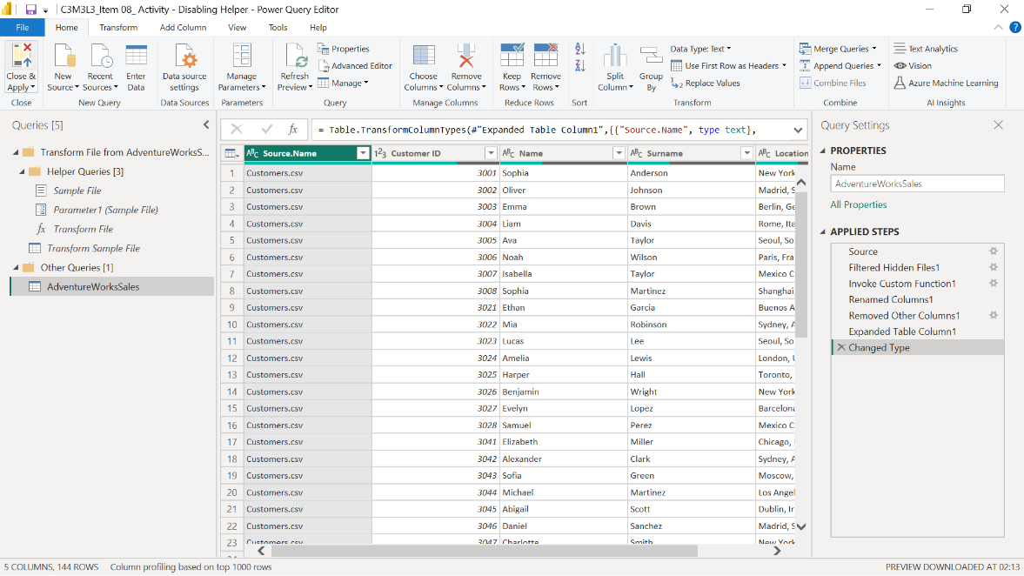

1. Select the *AdventureWorksSales* query to highlight it. You've just selected a combined query named after the imported folder, *AdventureWorksSales*.
2. Move your pointer over the query name and **right-click** to open a shortcut menu.

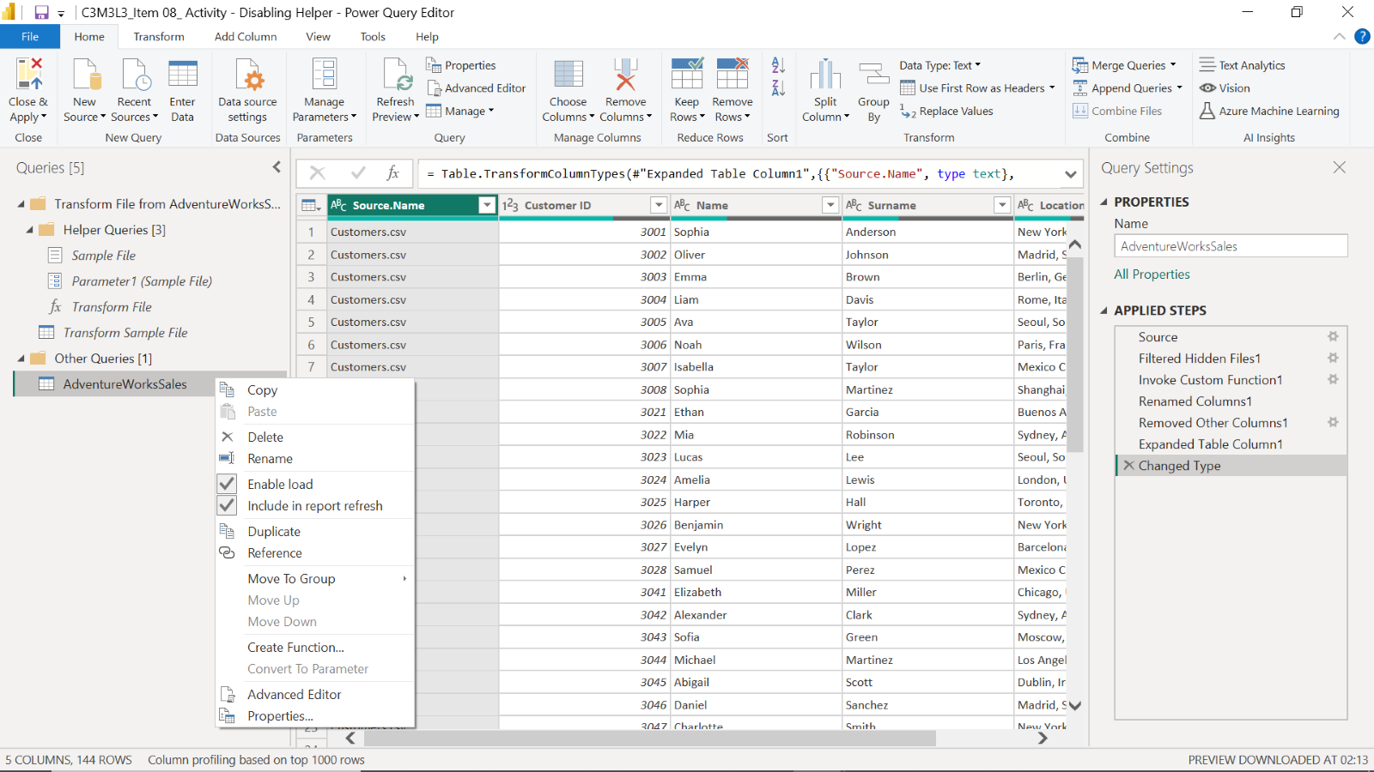

1. Among the various options in the shortcut menu, notice the **Enable Load** option. If this option has a checkmark next to it, it means the query is currently set to load its data into your model.
2. Select the **Enable Load** option in the **Context** menu. This removes the check mark next to the option, indicating that the query is not to load its data into your model, thereby disabling helper queries. If a new alert box called **Possible Data Loss Warning** appears, select **Continue**.

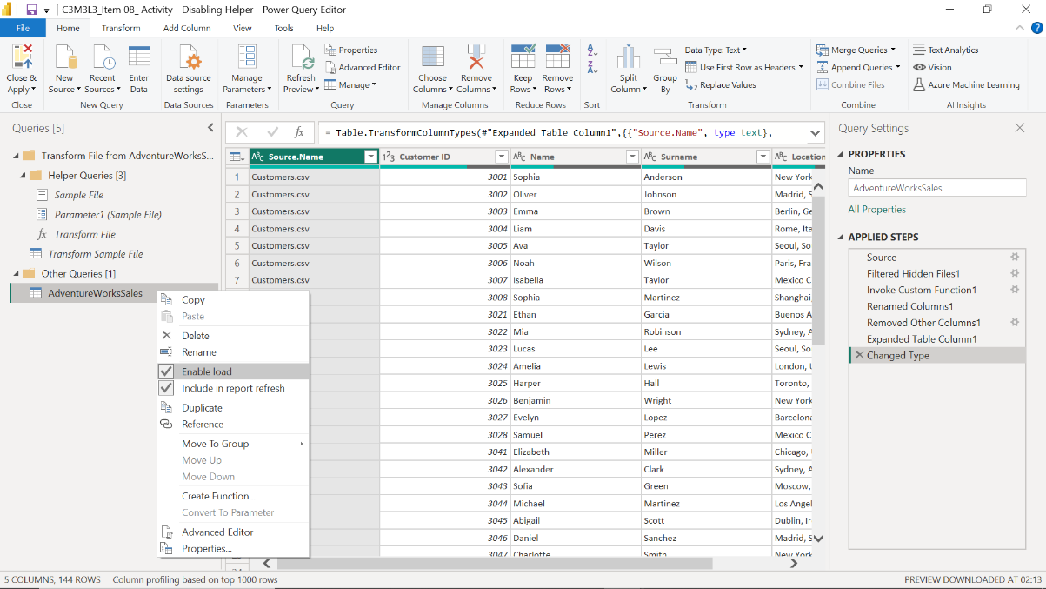

1. When you’ve finished disabling all unneeded queries, on the extreme left of the **Home** tab of the Power Query Editor select **Close & Apply** to save your changes and close the Power Query Editor.

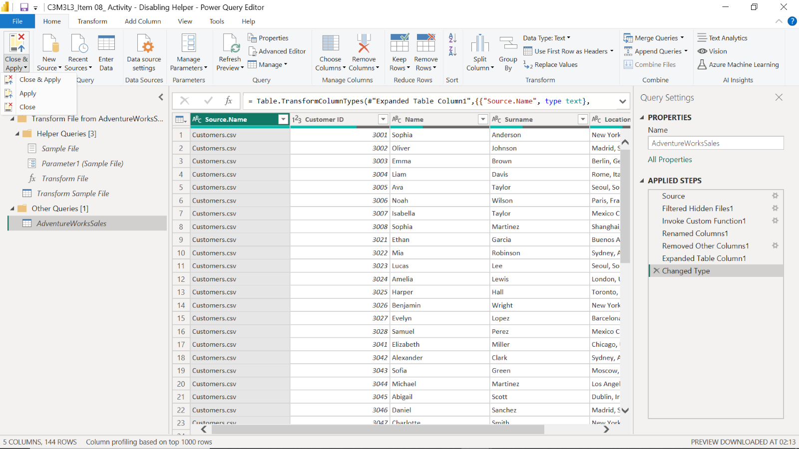

1. Now you’re back on the main screen of Power BI Desktop. You can continue creating or modifying visualizations, setting up relationships, and so forth. The data from the disabled queries will no longer be loaded into your model. The queries you’ve disabled are still listed in the Queries pane on the left in the Power Query Editor. However, they are no longer loading data into your model.
2. If you decide you want the data from these queries in your model again, you can easily re-enable them. Simply go back into the Power Query Editor, right-click on the query, and choose **Enable Load** to put a checkmark next to it.

**Conclusion**

With data analysis, the path to insightful results often involves a considerable amount of data transformation and cleanup. In Power BI Desktop, this process is simplified and made efficient by the use of helper queries. Their background work ensures your data is always in the right shape for analysis. Although useful, it's essential to consider the resource implications of these tools. Every query, including a helper query, consumes memory and processing power. Unmanaged, they can unintentionally slow down your report refreshes. Therefore, learning how to disable unnecessary helper queries gives you control of your reports’ performance. As you continue your journey with Power BI and beyond, embrace the adventure, and think of every data set, every query, and every insight as a step in your journey to master data analysis.